HACKATHON

Software Requirements Specification

|  |  |  |  |
| --- | --- | --- | --- |
|  | Prepared By | Reviewed By | Approved By |
| Name | Binary Beasts | Lakshmi Priya |  |
| Role | GenC’s | Batch Trainer |  |

**Table of Contents**

Table of Contents…………………………………………………………..….......II

1. Introduction…………………………………………………………………..…1

1.1 Intended Audience……………………………………………….......1

1.2 Project Scope…………………………...……………………………1

2. Overall Description…………………………………………….……………….1

2.1 Operating Environment……………………...……………………....1

3. Requirements……………………………………………………………...…….

3.1.1 FunctionalRequirements………………………………………………....

3.1.1.1 Req0001.…..……………………………………………………….2

3.1.1.2 Req0002.…..……………………………………………………….1

3.1.1.3 Req0003.…..……………………………………………………….1

3.1.1.4 Req0004.…..……………………………………………………….1

**1. Introduction**

Urbanladder is an e-commerce website for furnitures. We are taking and testing functionality of that website.

**1.1 Intended Audience**

Business Unit (BU) SME

Academy coach

Technical Trainer

**1.2 Project Scope**

This document defines at a functional level of the business activities that are encompassed by the system and the rules that apply to them. It also encompasses some of the key high and low level technical requirements of the system.

It draws heavily on both proposed Framework and Business Rules and the Technical Architecture documents. The scope of the detailed analysis project phase specifies that this document will include.

· Classification of requirements according to their functional areas.

· A description of each process in the system, including their inputs, outputs, and data transformation rules.

**2. Overall Description**

**2.1 Operating Environment**

Windows operating system

Web application

**3. Requirements**

This part of the requirements document serves to present the “BookShelves”, “Study chairs” and “Gift Card” sections of the “Urbanladder” website and also we need to extract all the options under “Being-At-home” from “Collections”.

**3.1.1 Functional Requirements**

**3.1.1.1 Req0001**

**Req0001a**-The user enters the text as ‘Book’ in the search box and selects “Book Shelf” from the auto suggestion list box.

**Req0001b**-To verify the display of BookShelves before applying any type of filters available in the website.

**Req0001c-**The user clicks on the “Category” filter and selects “BookShelves” from it.

**Req0001d-**  The user clicks on the “Price” filter and adjusts the slider to set maximum price as ‘15000’.

**Req0001e-** The user clicks on the “Storage Type” filter and selects “Open Storage” from it.

**Req0001f-** The user clicks on the “Exclude Out Of Stock” check box field.

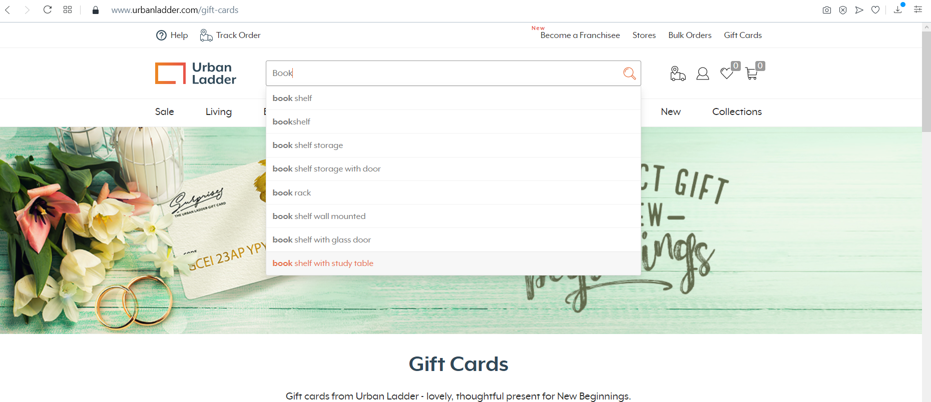

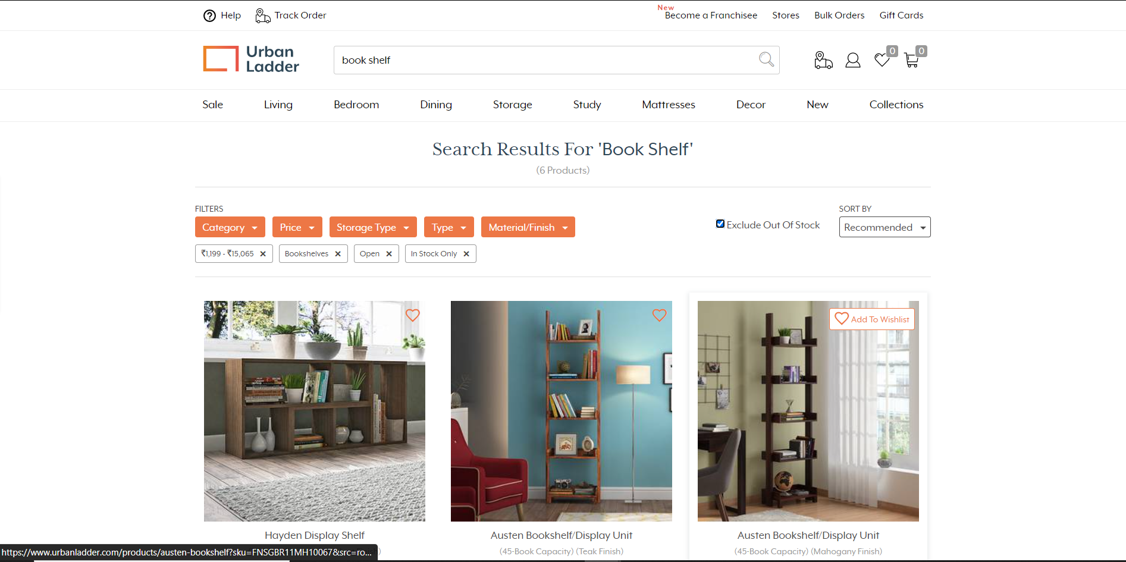

**3.1.1.2 Req0002**

**Req0002a**-The user places the mouse over the “Collections” menu.

**Req0002b**--To verify the display of all the submenu items under “Being At Home”.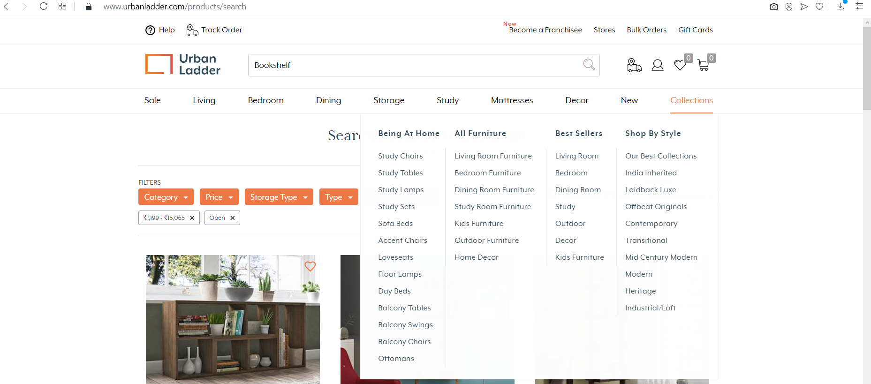

**3.1.1.3 Req0003**

**Req0003a -** The user clicks on “Gift Cards”

**Req0003b -** The user clicks on “Birthday/Anniversary” under ‘First, choose an occasion’ label.

**Req0003c -** Enter values to the required field and click “Next”.

**Req0003d -** Enter non-numeric values to “your mobile” textbox and valid values to all other mandatory fields and click confirm.

**Req0003e-** Click on “PROCEED TO PAYMENT” andCapture the error message.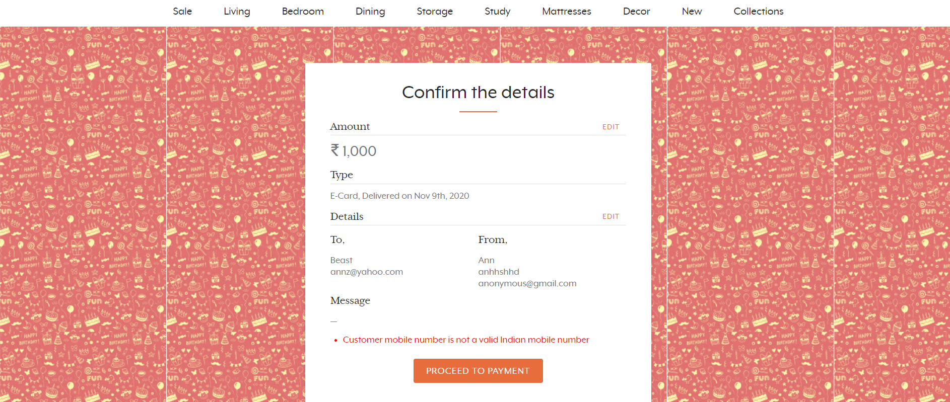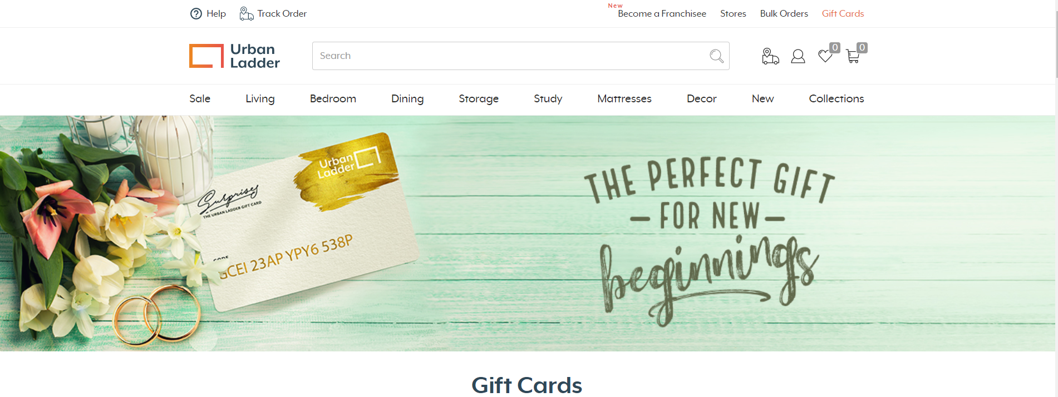

**3.1.1.4 Req0004**

**Req0001a**- The user enters the text as ‘study chair’ in the search box and selects “study chair” from the auto suggestion list box.

**Req0001b**- To verify the display of Study Chairs before applying any type of filters available in the website.

**Req0001c-**The user selects the option “Recommended” from the “SORT BY” dropdown list.

